Solutions page

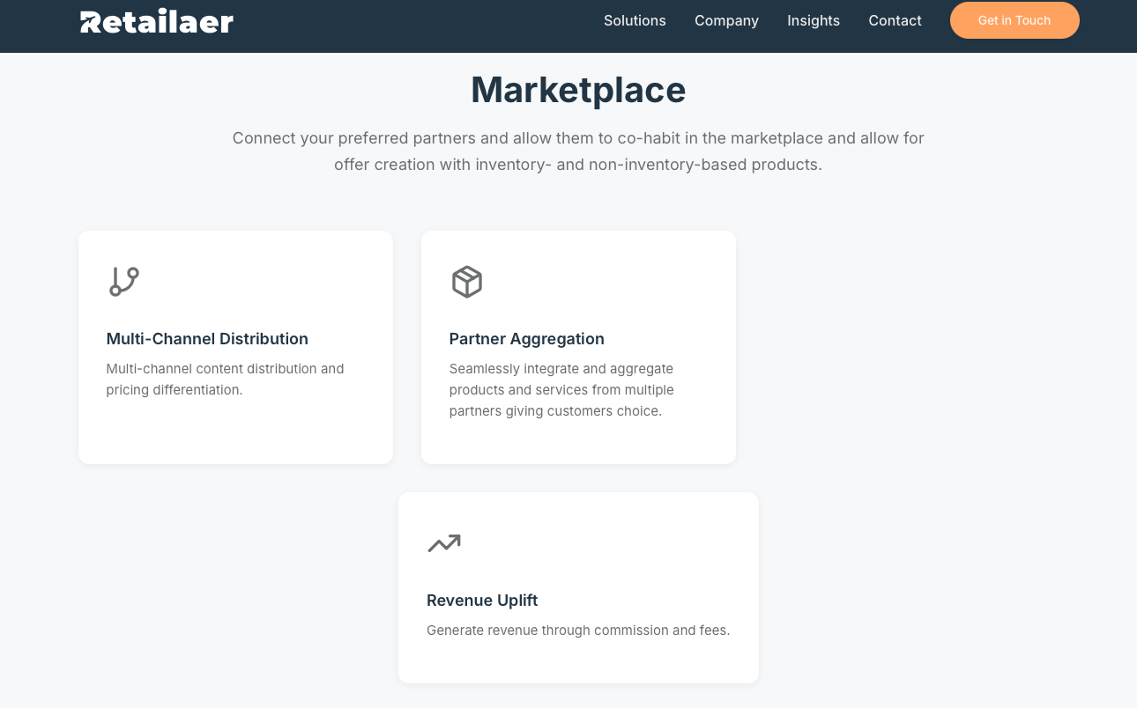

On web, Revenue uplift should be to the right of the other two boxes.

Company page

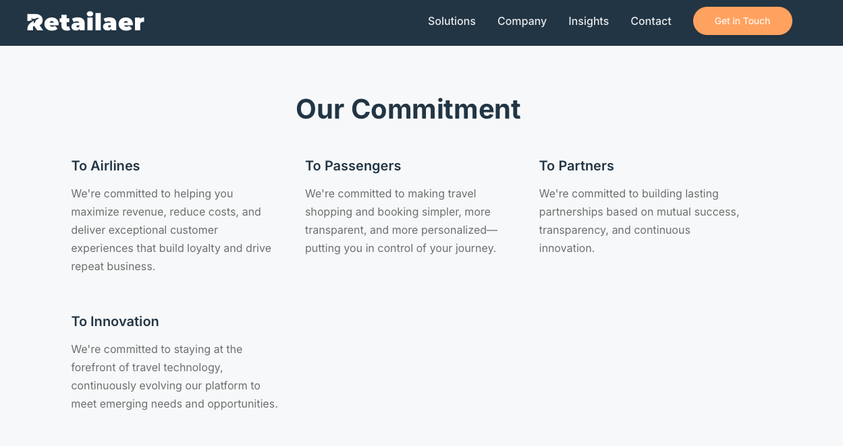

Can we fit them either 2-by-2 or all 4 on a single row?

Contact page

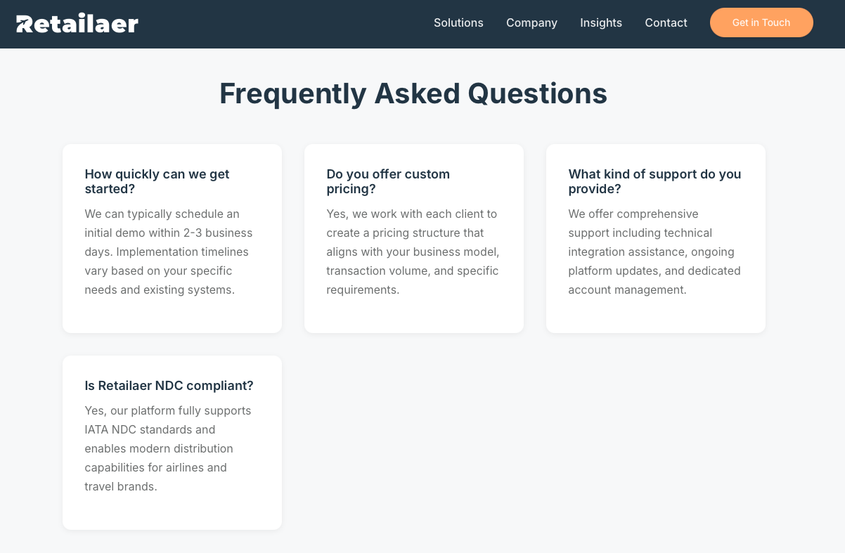

Can we pick 2 more FAQ’s to have a total of 6 or remove 1 to only have 3.

FAQ page

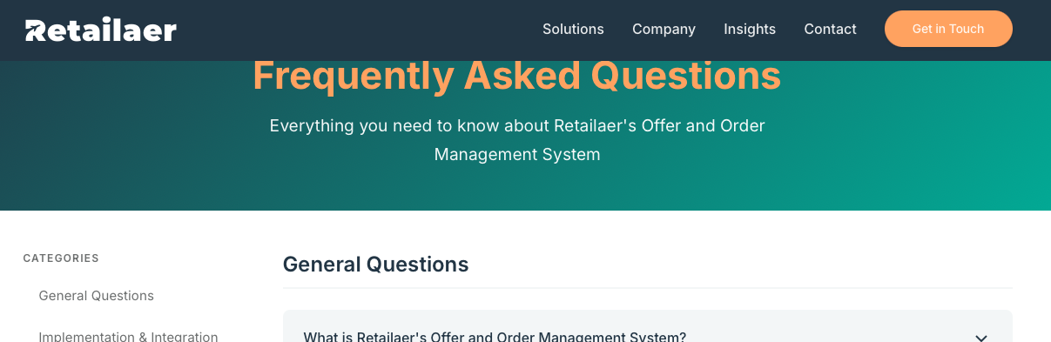

Top needs a bit more room like the other pages. Also, we have changed from white to orange text in the title. All other pages have like this:


Contact page
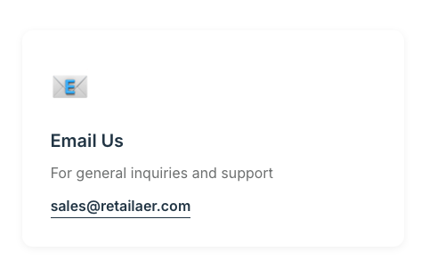

Let’s use info@retailaer.com just as we are doing in the footer.

Landing page



Remove Why Leading Airlines Choose Us ->, it’s the next section anyways and currently scrolls user to wrong section.

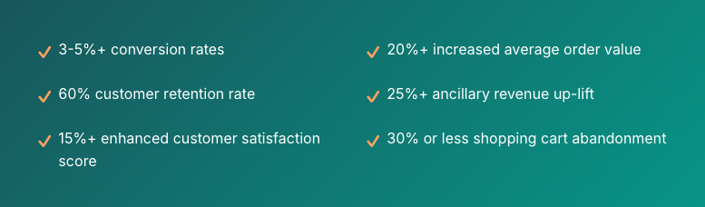

- 3-5%+ conversion rates
- 12-15% increased average order value
- 60% customer retention rate
- 15-25%+ ancillary revenue up-lift
- 15%+ enhanced customer satisfaction score
- 30% or less shopping cart abandonment

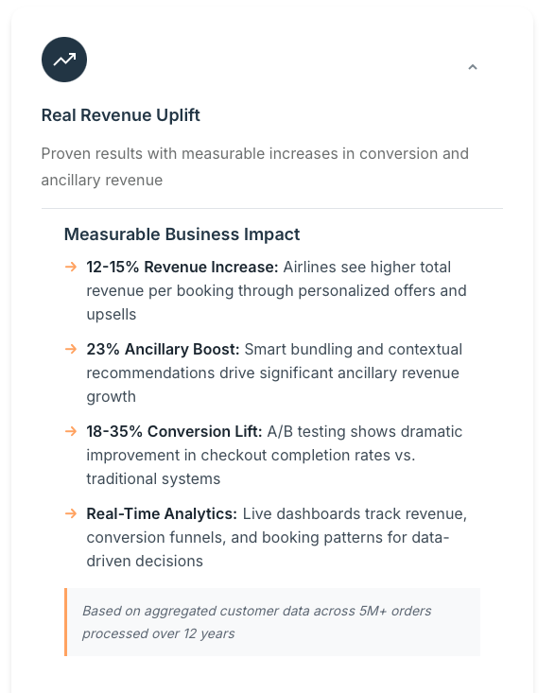

5-10% Conversion Lift

And consistency with Company page:

Based on aggregated customer data across 204M+ orders…

Terms of Services page

Do we need this page?

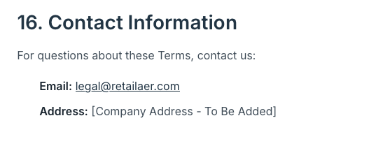
Let’s use info@retailaer.com
5th Floor, 18 St. Swithin's Lane, London, EC4N 8AD, UK

Privacy page

Let’s use info@retailaer.com

